**CSE 404  
Digital System Design Sessional (January 2018 Semester)  
Assignment-1**

**4-bit ALU Design Specification**

**Required Flags:**  
• Carry  
• Sign  
• Overflow  
• Zero

**Design and Implementation Issues:**  
• All outputs and flag status must be directed to LED.  
• Flags will be affected as per the rules of Assembly Language.  
• Any SSI (AND, OR, NOT, XOR etc.) and MSI (MUX, Decoder, Adder etc.) chip can be used.  
• Emphasis should be given on efficiency of design and minimization of ICs used.  
• Late submission will result in reduced marking.  
• For simulation you can use any software (like Proteus).  
• While demonstration you must bring your group specification.  
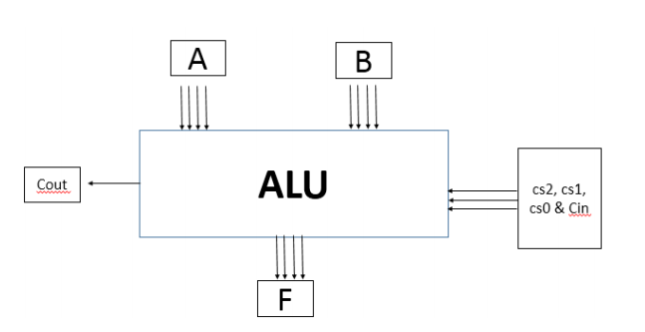

Note: Design Specifications for all groups are given in the “**Alu Design specs For all groups.xls**” file.